Infrared Emitter

Overview  
 This course will use the Raspberry Pi to control the infrared emission from the infrared emission tube and show the working status of the infrared emission tube through the LED light.

Experimental Materials

RaspberryPi *1

Breadboard *1

InfraredEmitter *1

InfraredEmission *1

Led *1

Dupont Line

Ready to work  
1. Install python interpreter in your Raspberry Pi system  
2. Install the RPi.GPIO library in your Raspberry Pi system  
3. Install the wiringPi library in your Raspberry Pi system  
See the attached "Installing a Python Interpreter and Corresponding Libraries in a Raspberry Pi System" for details.

Product description

I. Introduction:

Infrared remote control is currently one of the most widely used communications and remote control methods.The infrared remote control device has the characteristics of small size, low power consumption, strong functions, and low cost. It is also used on recorders, audio equipment, air-conditioner,toys and other small electronic devices after the color television and video recorder.Infrared light emitting diodes convert electrical signals into infrared light signals.An infrared light emitting diode is a special type of light emitting diode. It will emit infrared light when voltage is applied to both feet. When we add a pulsed voltage to both of its legs, it emits a pulsed light signal.

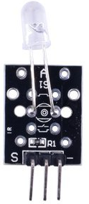

Characteristic parameters

◆ Forward current: 30~60mA ◆ Reverse breakdown voltage: 5V  
◆ Dissipation power: 90mW ◆ Operating temperature range: -25°C~+80°C  
◆Storage temperature range: -40°C~+100°C ◆Welding temperature: 260°C  
◆The module is soldered with a 1KΩ pull-up resistor

◆The pull-up resistor is connected to 5V

Wiring diagram

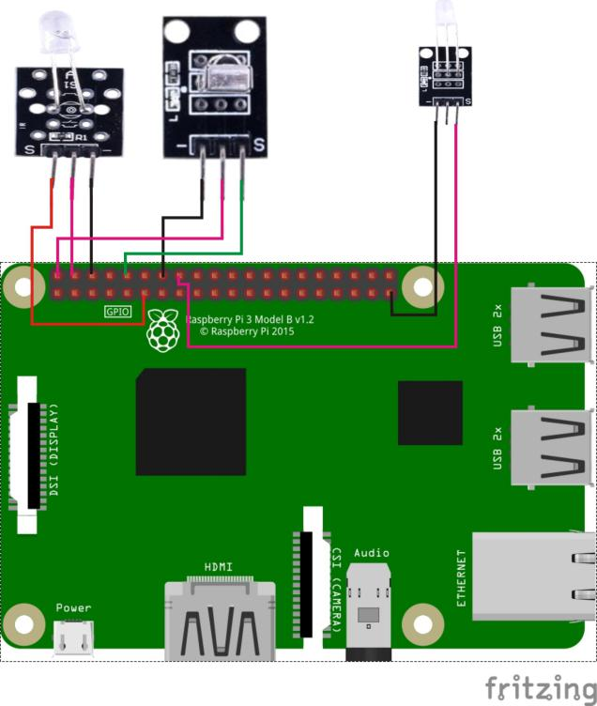

Sample code

1. Python code

#!/usr/bin/env python

import RPi.GPIO as GPIO

import time

IrReceiverPin = 10

IrEmissionPin = 11

LedPin = 16

Led_status = 1

def setup():

GPIO.setmode(GPIO.BOARD) # Numbers GPIOs by physical location

GPIO.setup(LedPin, GPIO.OUT) # Set LedPin's mode is output

GPIO.setup(IrReceiverPin, GPIO.IN, pull_up_down=GPIO.PUD_UP)

GPIO.setup(IrEmissionPin, GPIO.OUT) # Set IrPin's mode is output

GPIO.output(LedPin, GPIO.LOW) # Set LedPin low to off led

def swLed(ev=None):

global Led_status

Led_status = not Led_status

GPIO.output(LedPin, Led_status) # switch led status(on-->off; off-->on)

print("receive signal!\n")

time.sleep(0.1)

GPIO.output(LedPin, False)

def loop():

GPIO.add_event_detect(IrReceiverPin, GPIO.FALLING, callback=swLed) # wait for falling

while True:

print '...IrPin high'

GPIO.output(IrEmissionPin, GPIO.HIGH) # IrPin on

time.sleep(0.5)

print 'IrPin low...'

GPIO.output(IrEmissionPin, GPIO.LOW) # IrPin off

time.sleep(0.5)

def destroy():

GPIO.output(LedPin, GPIO.LOW) # led off

GPIO.cleanup() # Release resource

if __name__ == '__main__': # Program start from here

setup()

try:

loop()

except KeyboardInterrupt: # When 'Ctrl+C' is pressed, the child program destroy() will be executed.

print("KeyboardInterrupt.\n")

destroy()

2.C code

#include <wiringPi.h>

#include <stdio.h>

#define IrEmissionPin 0

#define IrReceiverPin 16

#define LedPin 4

int cnt = 0;

void myISR(void)

{

printf("Recevied infrared. cnt = %d\n", ++cnt);

if(digitalRead(LedPin) == HIGH)

{

digitalWrite(LedPin, LOW);

}

else

{

digitalWrite(LedPin, HIGH);

}

delay(100);

digitalWrite(LedPin, LOW);

}

int main(void)

{

if(wiringPiSetup() == -1)

{

printf("setup wiringPi failed !\n");

return -1;

}

pinMode(LedPin, OUTPUT);

pinMode(IrEmissionPin, OUTPUT);

pinMode(IrReceiverPin, INPUT);

pullUpDnControl(IrReceiverPin, PUD_UP)

if(wiringPiISR(IrReceiverPin, INT_EDGE_FALLING, &myISR) == -1)

{

printf("setup ISR failed !");

return -1;

}

while(1)

{

digitalWrite(IrEmissionPin, HIGH);

printf("IrEmissionPin is set High\n");

delay(500);

digitalWrite(IrEmissionPin, LOW);

printf("IrEmissionPin is set Low\n");

delay(500);

}

return 0;

}

Experimental phenomena

With the work of the infrared emission tube, the LED will keep on and off.